**CS551 ADVANCED SOFTWARE ENGINEERING**

**PROJECT- FOURTH INCREMENT- GROUP 4**

**OCCASIONS ON THE GO**

**Team Members:**

AnudeepVattipalli(16158489)

PoojithaMittapally(16157740)

Prathyusha Dinne(16161128)

**Introduction:**

Planning an event is very simple and is on high demand. To plan an event, you need to select every vendor, login to their websites and order the required services. Also, it will be difficult to adapt to different patterns and designs as each vendor has their own in built design. To avoid these problems, our project acts as a single stop where in user can find different vendors in one place with a common user interface (UI). This project provides feasibility to order services both through mobile and web applications. In this application, both users and vendors can take advantage as user will be provided with best deals and vendor can attract customers by giving offers.

**GitHub Link:**

<https://github.com/pdrk2/Increment4>

**ScrumDo Link:**

http://www.scrumdo.com/projects/project/one-stop/iteration/92459

**YouTube Link:**

<https://www.youtube.com/watch?v=zA_qpDU_RzA>

**Implementation Status Report:**

**Work Completed till 4th Increment:**

In fourth increment addition to what has been done in third increment, we have implemented online live chat communication between user and vendor as 24 * 7 service. Other features which we have developed include videos uploading, retrieving and displaying on each vendor’s page. Also, we have used weather API in our website through which user will have the option to check the weather on a particular date and in a particular location in order to schedule the event date accordingly. We have also designed text to speech API implementation where user upon clicking a button will be given all information about respective vendor. On the other hand, we have also made our website look with rich and simple UI design. The video production was also done for whole project/website.

* Text to speech API implementation in our website
* Online live chat communication between user and vendor
* Weather API integration
* Upload, retrieve and display videos for each vendor
* Rich and simple UI design
* Website video production

**Web Services:**

The webservices which we developed were:

1. Order details
2. Vendor menus
3. Item find
4. Login web services
5. Search engine

Order details web services have the following methods:

1. Adding user and vendor details respective to the order
2. Adding user order address details
3. User can view the orders
4. Vendor can view the orders

Vendor Menu and Item find webservice has the following methods:

1. Adding Menu items (for Catering and Theme Vendors )
2. Editing Menu items
3. Retrieval of menu items
4. Adding services for vendors (for Photography and Venue Vendors)
5. Editing services for vendors
6. Search results to display the searching item

**Order Details Table:**

This table consists of all queries Used for this table were:

a) insert into order_details (user_id,ven_id,details,total) values('" + user_id + "','" + ven_id + "','" + details + "','" + total + "');

b) UPDATE order_details SET email = '" + email + "', street = '" + street + "', city = '" + city + "', state = '" + state + "' , phone = '" + phone + "', date = '" + yDate + "' where id = '" + id + "'"

c) select * from order_details where ven_id = '" + ven_id + "'"

**Implementation of Services:**

Below services developed as part of this increment is:

1. Text to Speech Implementation
2. Weather API
3. Online live chat communication
4. Video retrieving and displaying for each vendor

As part of user interface, we have implemented sliding of images on the web pages for effective web page view.

**Screenshots of Web Application:**

**Retrieving and displaying videos for each vendor:**

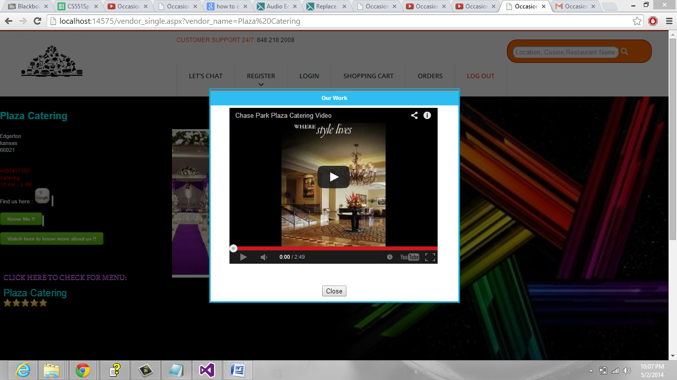

**Event Date can be selected and weather can be seen at a particular date and location before scheduling an event:**

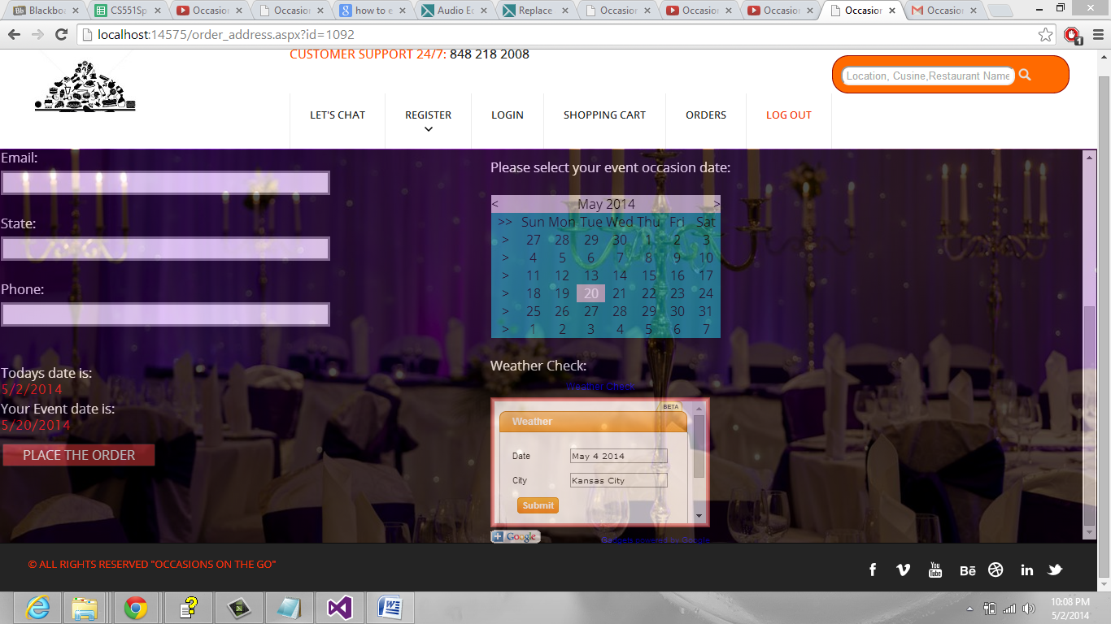

**Weather Check and Report:**

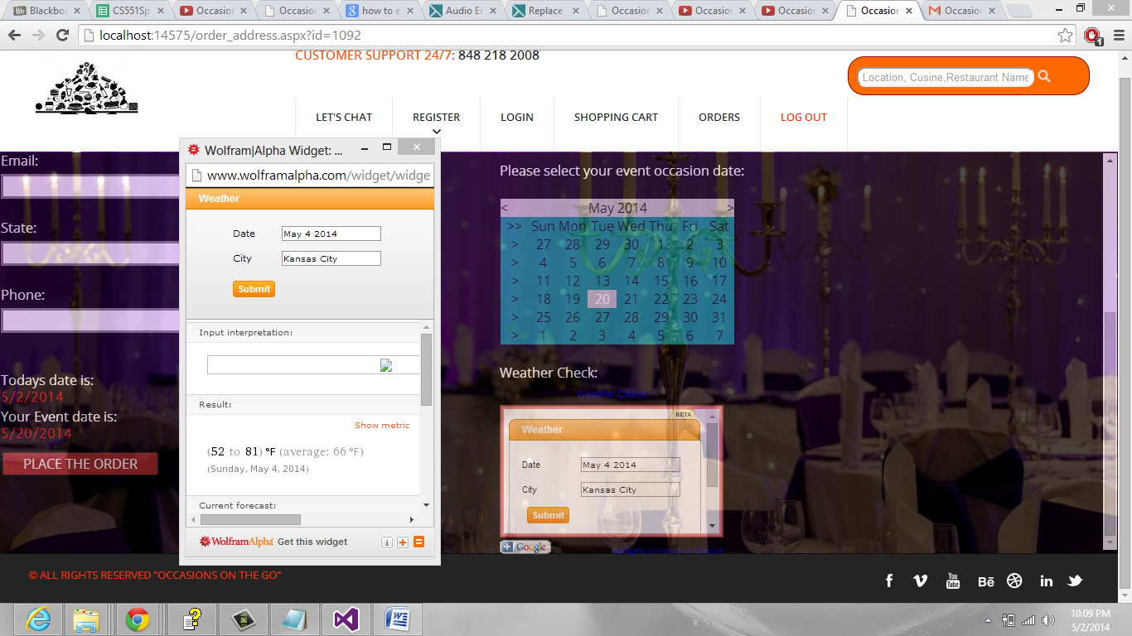

**Online Live chat communication between vendor and user:**

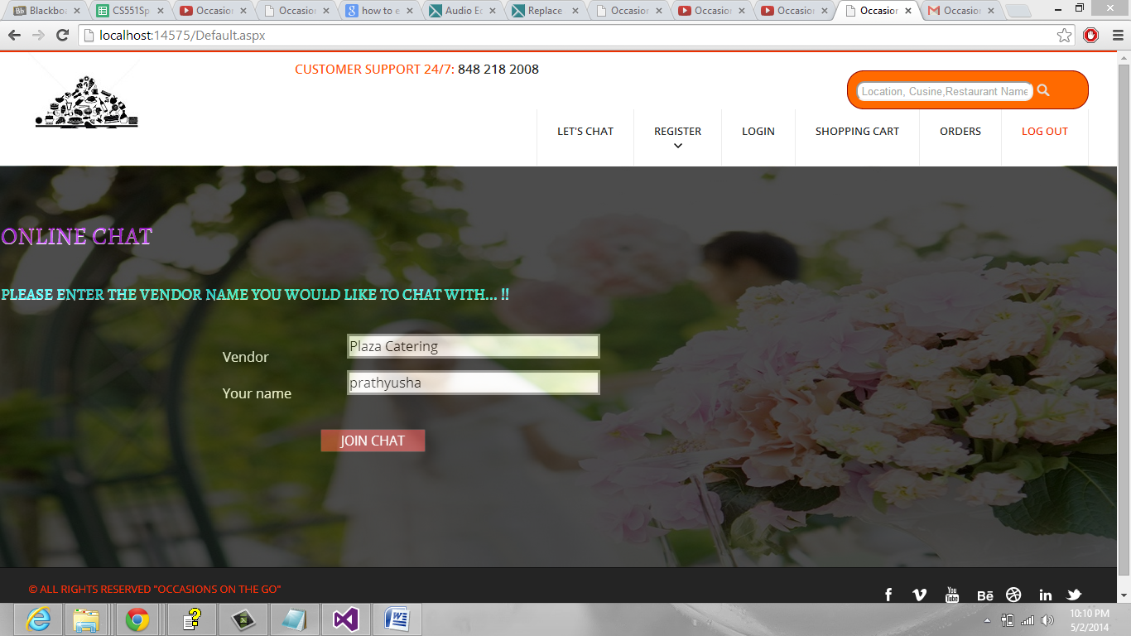

**Chat Window:**

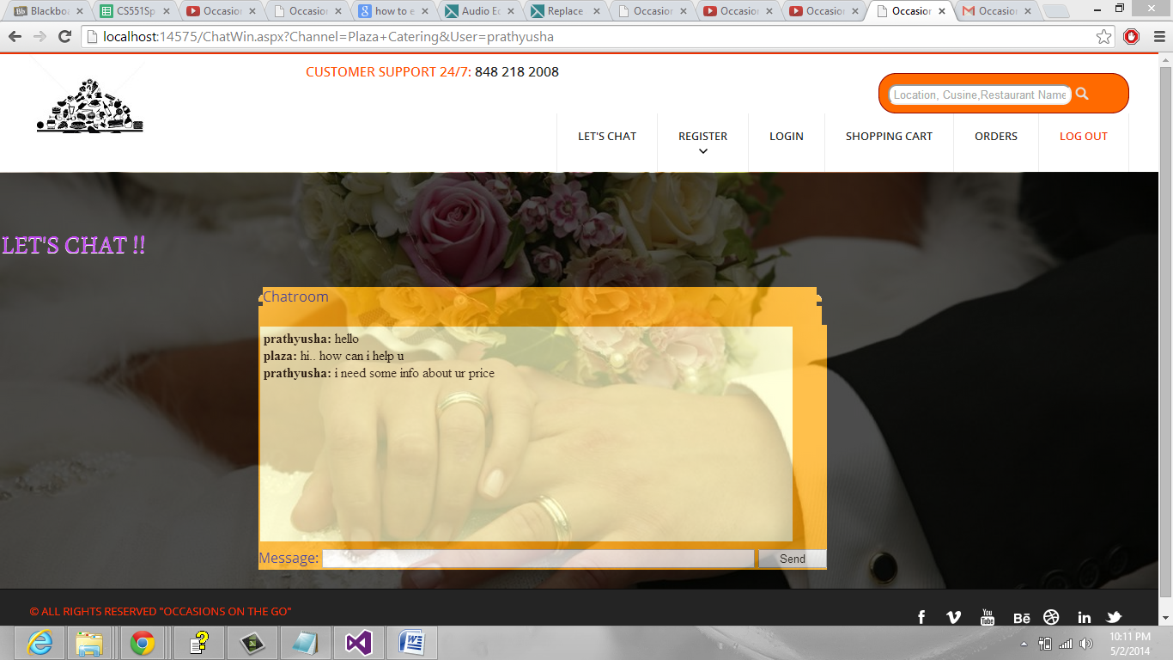

**Text to speech API implementation by clicking on know me button:**

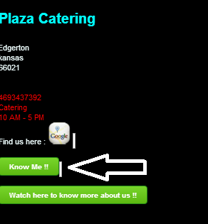

**Work completed in 4th increment:**

**Responsibilities:**

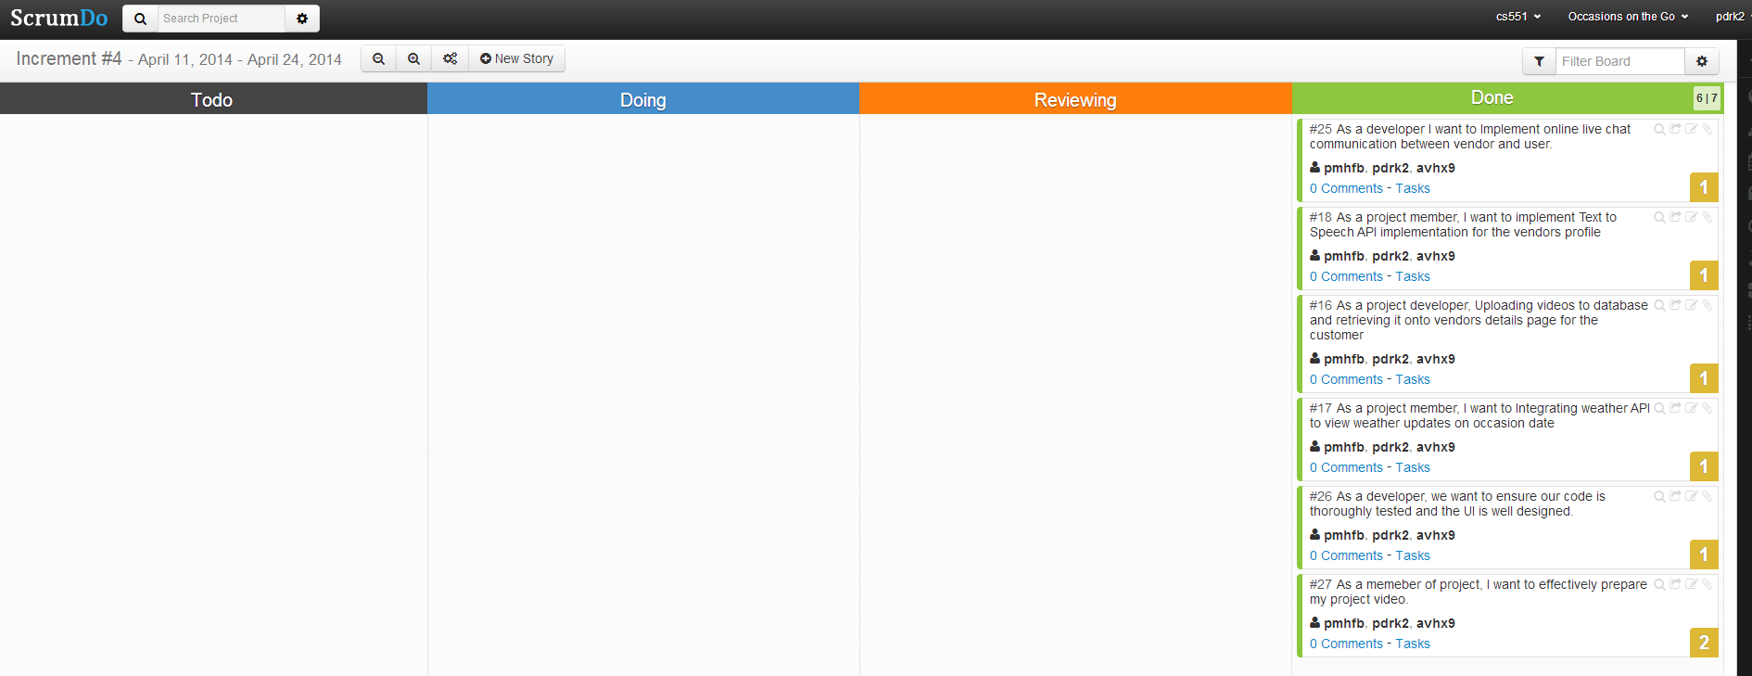

|  |  |  |
| --- | --- | --- |
| **Sl.No** | **Task** | **Person involved** |
| 1. | Text to Speech API implementation for the vendors profile | Prathyusha  Poojitha  Anudeep |
| 2. | Uploading videos to database and retrieving it onto vendors details page for the customer | Anudeep |
| 3. | Integrating weather API to view weather updates on occasion date | Poojitha |
| 4. | Online live chat communication between user and vendor | Prathyusha |
| 5. | User Interface Design &Testing | Anudeep  Prathyusha  Poojitha |
| 6. | Video production &Documentation | Prathyusha  Anudeep  Poojitha |